Supplementary S1. Terminology mapping and search exhaustiveness validation for the systematic literature review.

S1.1 Purpose
This supplementary file contains two components. The first component documents the terminology mapping used to reduce the risk of an incomplete or biased keyword set for the literature search on mHealth security requirements by refining the search vocabulary and deriving wildcard nouns for the PICO search domains. Keyword co-occurrence analysis was used exclusively to harmonize terms, remove clearly irrelevant generic words, and derive wildcard nouns that resulted in the final PICO query formulation across four search domains, with the resulting co-occurrence map provided as Figure S1.6. The second component documents the procedure used to validate search exhaustiveness through an expanded retrieval and a random-sample verification.

Part A. Terminology mapping

S1.2 Data source and corpus definition
We used Scopus as the bibliographic source to build a broad terminology corpus related to security in the health domain. The corpus was retrieved using the following query:
TITLE-ABS-KEY ( security AND health )
The time window was not restricted to a specific date. This corpus was used for terminology discovery to support query refinement and reduce the risk of omitting commonly used terms in the target research space.
Sampling rationale. Due to limitations in exporting records from Scopus, the keyword co-occurrence analysis was performed using the last 20,000 most-cited records from the retrieved full corpus, yielding n = 99,384. This sampling approach was used as a practical indicator for discovering and grouping frequent terms, rather than as an inferential estimate of the full corpus.

S1.3 Keyword extraction and occurrence thresholding
Keywords were obtained from the Scopus export and aggregated into an initial candidate set for mapping. To focus on stable and recurring concepts, we retained terms meeting the following frequency rule:
- Minimum occurrence threshold: at least 55 occurrences in the 20,000-record sample.
This threshold was used to reduce noise from rare or idiosyncratic descriptors while retaining commonly encountered terminology.

S1.4 Cleaning and harmonization rules
Before generating the co-occurrence map, the authors harmonized terminology to reduce redundancy and remove obvious noise based on them expertise. The following cleaning rules were applied deterministically:
- Synonym merging. Terms with equivalent meaning were unified into a single preferred label such as consolidating “electronic medical record” and “EMR” when used to refer to the same concept.
- Abbreviation handling. Abbreviations with unambiguous meaning in context were consolidated; ambiguous abbreviations were removed to prevent conflation of different concepts.
- Removal of generic publication descriptors. Terms clearly referring to publication types or generic research discourse rather than domain content were removed such as: “model”, “review”, “literature review”, “survey”, “article”.
- Removal of high-frequency non-target terms. High-frequency terms that did not contribute to identifying security requirements in mHealth within this study’s scope were removed when they did not improve query specificity.
- Spelling and variant unification. Minor spelling variants, pluralization differences, and trivial lexical variants were unified.

S1.5 VOSviewer configuration
The keyword co-occurrence map was generated using VOSviewer version 1.6.20 [1] with the following settings:
- Software: VOSviewer v1.6.20
- Type of analysis: Co-occurrence
- Unit of analysis: Keywords
- Counting method: Full counting
- Minimum number of occurrences: 55
- Thesaurus file: Not used

S1.6 Outputs
Figure S1.6 presents the keyword co-occurrence map derived from the Scopus sample after harmonization and filtering.
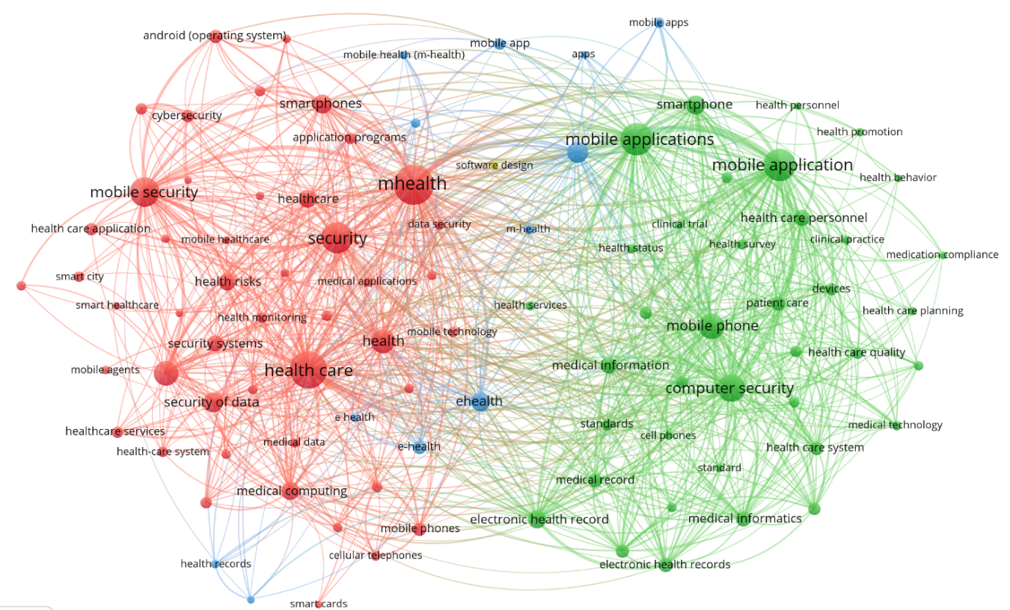
Figure S1.6: keyword co-occurrence map derived from the Scopus query

S1.7 Derived wildcard nouns for the four search domains for PICO refinement
The co-occurrence analysis supported the selection and harmonization of wildcard nouns used across the four search domains in the final search strategy. The purpose was to ensure that query terms capture common constructs associated with security implementation and security requirements in mHealth and related healthcare ICT contexts. The records exported in RIS format from Scopus, as well as the necessary files generated in VOSviewer, are available on GitHub.
The wildcard noun sets were operationalized as follows:
- Domain 1: mHealth and mobile ICT context terms: mHealth*, mobile health, smartphone*, Android*, mobile app*, telehealth*, remote monitoring*, wearable*, patient portal*, personal health record*.
- Domain 2: security requirements and controls terms: security requirement*, requirement specification*, security control*, confidentiality, integrity, availability, access control, authentication, authorization, cryptograph*, secure storage, encryption, key management, secure communication, secure session*, audit trail*.
- Domain 3: implementation, governance, and assurance terms: DevSecOps, CI/CD, secure SDLC, audit*, compliance, policy, privacy, regulation, governance, risk management, vulnerability management.
- Domain 4: evaluation and verification terms: assessment, verification, validation, test*, static analysis, dynamic analysis, penetration test*, vulnerability, risk, mitigation, evidence.
This terminology refinement step guided the formulation of wildcard nouns incorporated into the final PICO inquiry and served as an internal control to reduce missed-term risk.

S1.8 Notes on interpretation and limitations
This co-occurrence analysis was conducted to support terminology discovery and query refinement only. The output should not be interpreted as a bibliometric analysis of the security-and-health literature. The use of the last 20,000 records was driven by export constraints and was considered adequate for identifying high-frequency recurring terms to inform the search strategy.

Part B. Search exhaustiveness validation

S1.9 Validate search exhaustiveness

To maximize the retrieval of relevant primary evidence, there were no restrictions on publication date, and the search terms were broadened by incorporating the keywords “problem” and “challenge” into the population factor in Table S1.9. This strategy allowed the retrieval of 1423 articles published between 1994 and 2026; after removing 4 duplicates and excluding the 689 records from the initial search, a total of 730 new articles were obtained for processing.

Table S1.9: Software security PICO-adherent systematic literature review search query for recommendations on mHealth.
Scope | String
Population (P) | (("care*" OR "health*" OR "medic*" OR "clinic*" OR "issue" OR "challenge") AND
Intervention (I) | ("app" OR "mobile" OR "smartphone") AND
Control (C) | ("secur*") AND
Outcomes (O) | ("guide*" OR "requirement*" OR "criteri*" OR "catalog*" OR "specification*")) AND
 | (LIMIT-TO (SRCTYPE,"j"))
 | AND (LIMIT-TO (LANGUAGE,"English"))
 | AND (LIMIT-TO ( EXACTKEYWORD, "Mobile Security") OR LIMIT-TO (EXACTKEYWORD, "Software") OR LIMIT-TO ( EXACTKEYWORD, "Security And Privacy") OR LIMIT-TO (EXACTKEYWORD, "Mobile Apps") OR LIMIT-TO (EXACTKEYWORD, "Mobile Health") OR LIMIT-TO (EXACTKEYWORD, "Cryptography") OR LIMIT-TO (EXACTKEYWORD, "MHealth") OR LIMIT-TO (EXACTKEYWORD, "Mobile Applications") OR LIMIT-TO (EXACTKEYWORD, "Computer Security") OR LIMIT-TO ( EXACTKEYWORD, "Security") OR LIMIT-TO (EXACTKEYWORD, "Confidentiality") OR LIMIT-TO (EXACTKEYWORD, "Mobile Application") OR LIMIT-TO (EXACTKEYWORD, "Smartphone"))
 | AND (LIMIT-TO (SUBJAREA,"COMP") OR LIMIT-TO (SUBJAREA,"ENGI") OR LIMIT-TO (SUBJAREA,"HEAL") OR LIMIT-TO (SUBJAREA,"MEDI"))

A thorough literature review was conducted on the 730 records retrieved from the Scopus bibliographic database to assess the accuracy of findings on the security of mobile health applications. This review involved randomly selecting a sample of publications from the entire compilation and examining their relevance determined using the sample size equation proposed by Cochran (1) [2]
- $n=\frac{NZ^{2}p(1-p)}{\left(N-1\right)e^{2}+ Z^{2}p(1-p)}$
Where:
- n represents the quantity of documents chosen at random for validation,
- N denotes the aggregate number of publications extracted from the Scopus repository (730),
- Z indicates the divergence from the admitted mean ratio corresponding to the confidence interval (1.96 for a 95% confidence interval).
- e indicates the degree of uncertainty (0.05).
- p denotes the fraction of anticipated erroneous outcomes (0.08, arbitrarily selected and presumed to be minimal).
The representative sample of articles for validation was 99, and after reviewing them, no additional primary sources of security requirements were revealed beyond those already captured in the PRISMA-based evidence base, supporting the suitability of the initial search strategy for building the catalog.

References
[1] N. J. van Eck and L. Waltman, “Software survey: VOSviewer, a computer program for bibliometric mapping,” Scientometrics, vol. 84, no. 2, pp. 523–538, 2010, doi: 10.1007/s11192-009-0146-3.
[2] W. G. Cochran, Sampling techniques, 3rd ed. in Wiley series in probability and mathematical statistics. New York [etc: John Wiley & Sons, 1977.

https://url-shortener.me/AA82
https://url-shortener.me/C9QV

